**TECHNICAL GUIDE:**

**FOR LIVE WEBSITE**

**PLEASE CLICK THE LINK:** [**https://camerarentals.store/**](https://camerarentals.store/)

**For admin:**

[**https://camerarentals.store/admin**](https://camerarentals.store/admin)

**Used languages and technology**

Backend

We used PHP as backend .PHP is an open-source server-side scripting language that many devs use for **web development**. It is also a general-purpose language that you can use to make lots of projects, including Graphical User Interfaces.

Frontend

HTML, CSS, JavaScript: we used these languages in front end.

HTML: This provides the basic structure of sites, which is enhanced and modified by other technologies like CSS and JavaScript.

CSS: CSS stands for Cascading Style Sheets. This programming language dictates how the HTML elements of a website should appear on the frontend of the page.

JavaScript: JavaScript is a logic-based programming language that can be used to modify website content and make it behave in different ways in response to a user's actions. Common uses for JavaScript include confirmation boxes, calls-to-action, and adding new identities to existing information.

Database

We used MySQL for database, It is a tool used to **manage databases and servers**, so while it's not a database, it's widely used in relation to managing and organizing data in databases.

Framework

Laravel is a web application framework that is employed; it has an expressive and attractive syntax. They already set the groundwork, which frees us to develop without worrying about the little details. By making routine tasks like authentication, routing, sessions, and caching easier than they are in most online projects, Laravel aims to make development less painful. Laravel attempts to make the development process a pleasing one for the developer without losing application functionality.

Live website link: <https://camerarentals.store/>

Local host :

We hosted it at local host using Xampp server, Xampp is a completely free, easy to install Apache distribution containing PHP. The XAMPP open-source package has been set up to be incredibly easy to install and to use.

How to connect to the server

We used Gitbash to run the command and generate local host link, Git Bash is **an application that provides Git command line experience on the Operating System**. It is a command-line shell for enabling git with the command line in the system. A local host id is generated which is then copied to the browser to run the website.

We use the command “cd c/Xampp/htdocs/camera-rent then hit enter”

Then type “php artisan serve” then hit enter

Artisan

It is **the name of the command-line interface included with Laravel**. It provides several helpful commands for your use while developing your application.

PHP my admin

phpMyAdmin is a free software tool written in [PHP](https://php.net/), intended to handle the administration of [MySQL](https://www.mysql.com/) over the Web. phpMyAdmin supports a wide range of operations on MySQL. frequently used operations (managing databases, tables, columns, relations, indexes, users, permissions, etc.) can be performed via the user interface, while you still can directly execute any SQL statement.

S**ystem Requirements**

Hardware used : Local Machine ( Windows Laptop )  
**Configuration**   
Processor - Intel i5  
OS : Windows  
Software : Xampp Server to Run our PHP Files & MySQL database.  
 System Browser ( Chrome / Edge / Mozilla Firefox) to Access   
 Frontend & Backend panel.  
**Programing Language Used**  
Front End : HTML, CSS , Java script  
Backend : PHP  
Database : MySQL

**External Services Used**

* PayPal Payment Gateway for Payment Integration.
* Gmail SMTP server for Mailer Functionality.

**Architecture used**

we used MVC architecture for our website it is shown below in the figure. The **Model-View-Controller (MVC)** is an architectural pattern that separates an application into three main logical components: the **model**, the view, and the controller. Each of these components are built to handle specific development aspects of an application. MVC is one of the most frequently used industry-standard web development frameworks to create scalable and extensible projects.

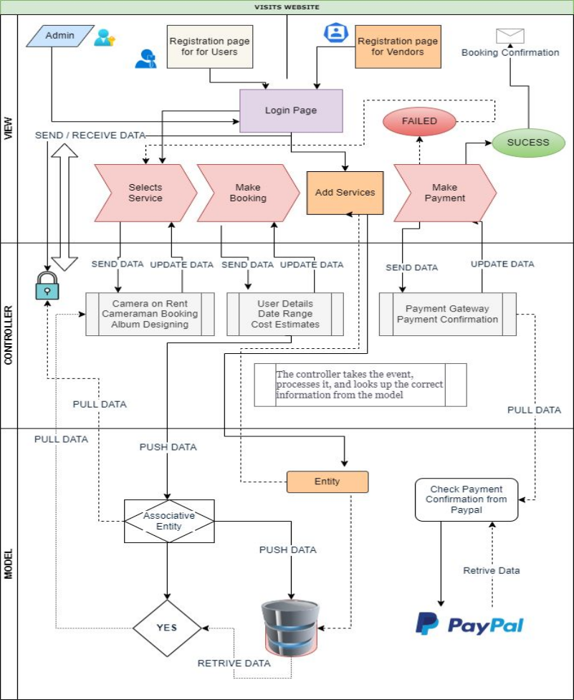

MVC architecture of photo and camera rental store

ERD DIAGRAM

